EIE3810 Microprocessor System Design Laboratory

Laboratory Report #1

Name: 马腾飞

Student ID: 121090406

Date: Sep 28,2023

The Chinese University of Hong Kong, Shenzhen

There are what experiments I have done during this lab as follows.

* Experiment 1: Set a GPIO as an output and drive a LED with standard peripheral library.
* Experiment 2: Read a key from GPIO input and drive an LED with a standard peripheral library
* Experiment 3: Set a GPIO as an output and drive an LED with register setting
* Experiment 4: Read a Key from GPIO input and drive an LED with register setting
* Experiment 5: Create my own library for the project board

1. **Experiment 1**
   1. Design
      1. Designed program flowchart

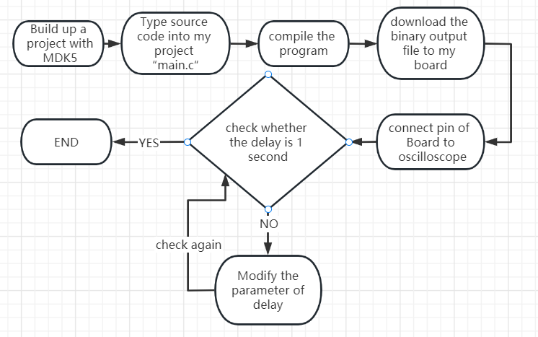

* + 1. Explanation of source code

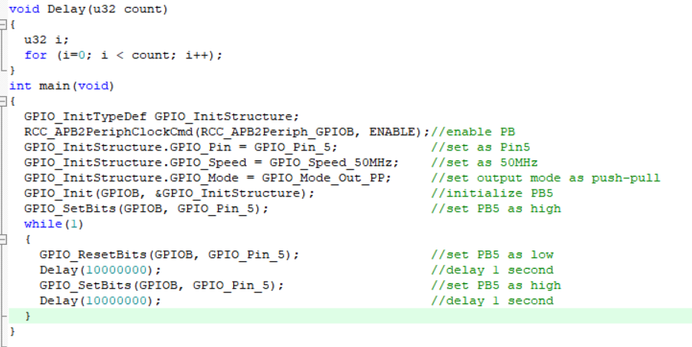

1. PB5 connects to LED0.
2. PB5 low means LED0 on.
3. Choose 10000000 delay is 1 second.
   1. Result

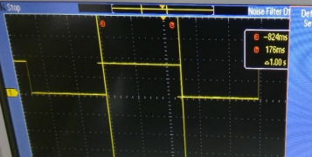

In the oscilloscope, there is periodical square wave with period 2 seconds. And the level changes every 1 second. The LED0 does as well.

* 1. Questions
     1. How do you validate that your error is less than 5%, i.e. the error in time periods for LED0 on and off should be less than 50ms?
     2. Use oscilloscope. Coordinate two lines to align with two near edges, and check the time difference. If it is 1.00 sec, it is done. If not, assume the period changes linearly with delay and calculate the right delay. If still not, change delay little by little (eg. 100 by 100).

1. **Experiment 2**
   1. Design
      1. Designed program flowchart

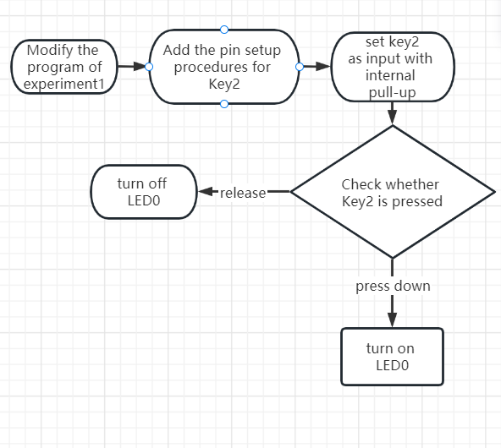

* + 1. Explanation of source code

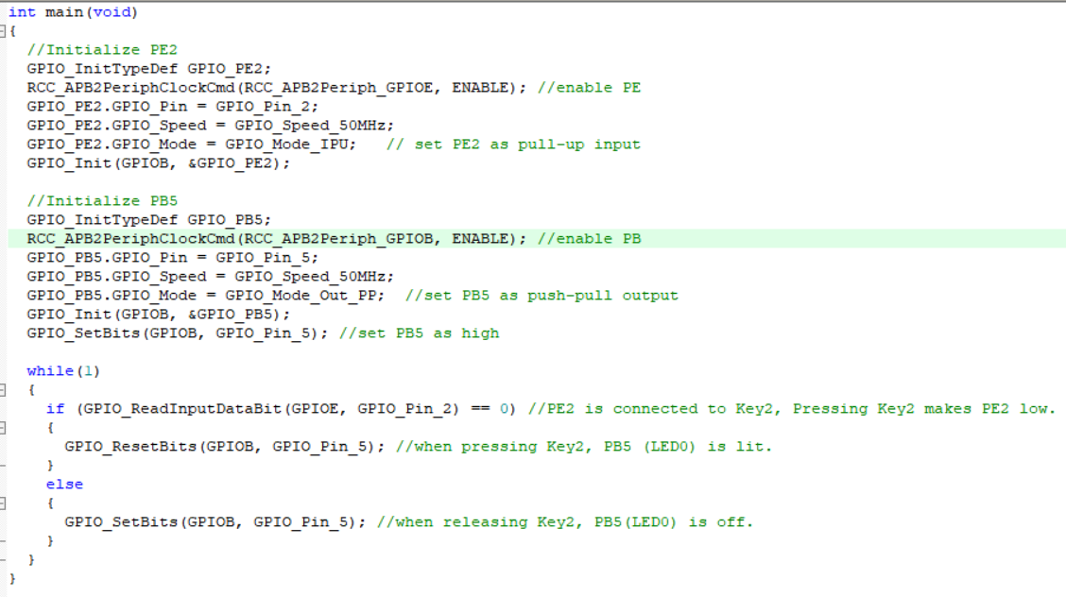

1. Initialize PE2 and PB5
2. Use a conditional statement to express the relation between LED0 and Key2
   1. Result

When pressing Key2, LED0 is on. When releasing Key2, LED0 is off.

* 1. Questions
     1. There no questions in the handout.

1. **Experiment 3**
   1. Design
      1. Designed program flowchart

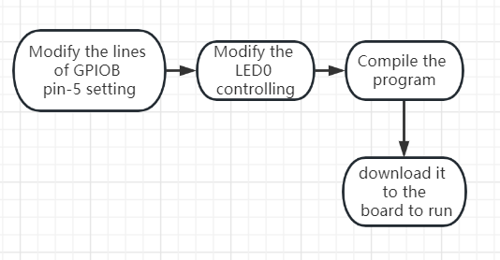

* + 1. Explanation of source code

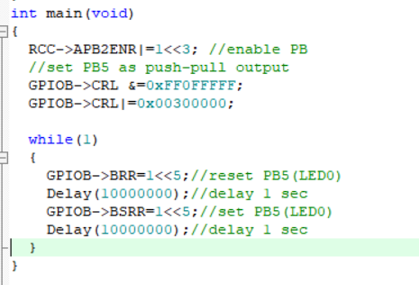

1. APB2ENR is used to enable GPIO, eg. Enable PB
2. CRL is to set output mode, in this case, we set the sixth(count from 0) port(from right) as 0b0011, which means push-pull output mode.
3. BRR means “reset”.
4. BSRR means “set”.
   1. Result



In the oscilloscope, there is periodical square wave with period 2 seconds. And the level changes every 1 second. The LED0 does as well.

* 1. Questions
     1. There no questions in the handout.

1. **Experiment 4**
   1. Design
      1. Designed program flowchart

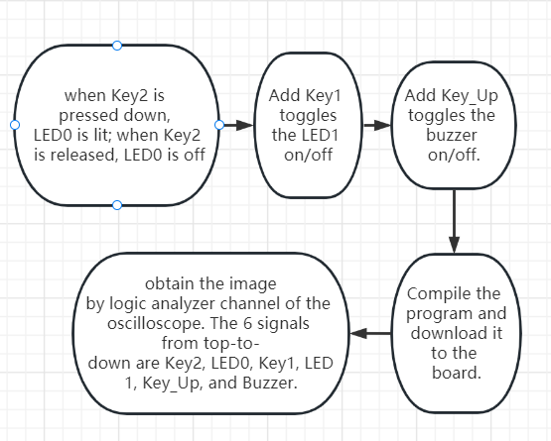

* + 1. Explanation of source code

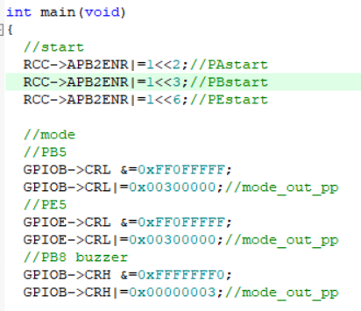

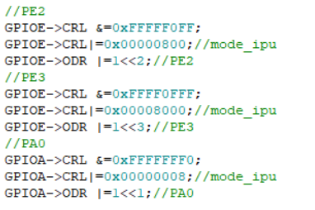

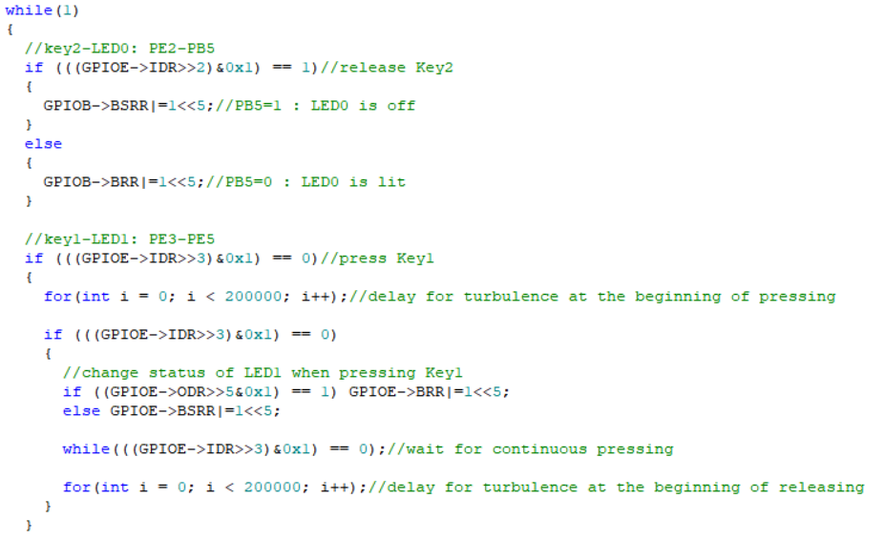

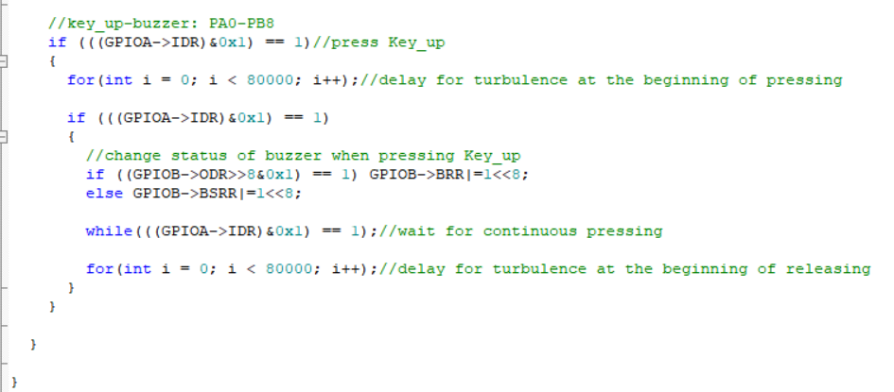

1. Initialize buzzer, keys, LEDs like experiment3
2. Use delay to deal with turbulence.
3. Notice the comments behind codes
   1. Result

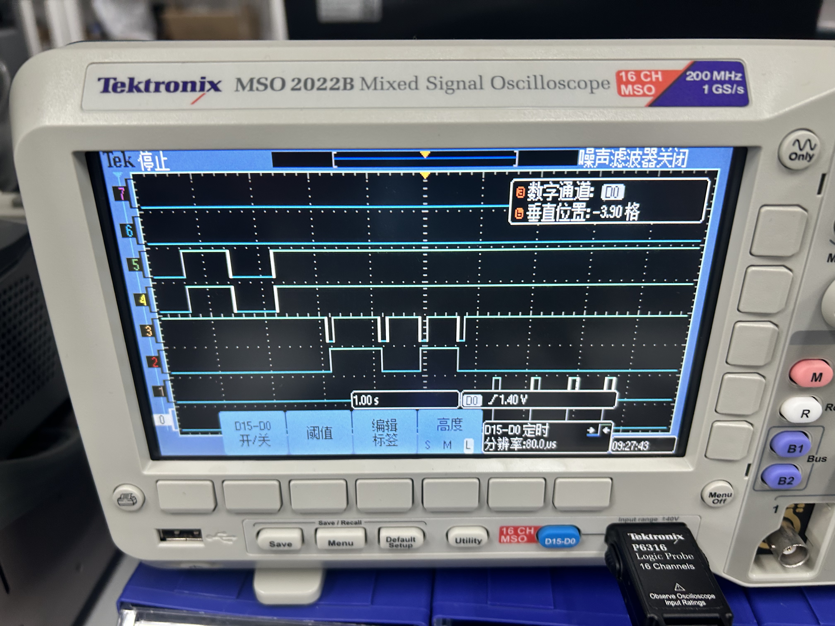

From top to down, they are Key2, LED0, Key1, LED1, Key_up and buzzer.

When pressing Key2, LED0 is on. When releasing Key2, LED0 is off.

Key1 toggles LED1, i.e. press and release Key1, and LED1 status is then flipped.

Key_up toggles buzzer, i.e. press and release Key_up, and buzzer status is then changed.

* 1. Questions
     1. There no questions in the handout.

1. **Experiment 5**
   1. Design
      1. Designed program flowchart

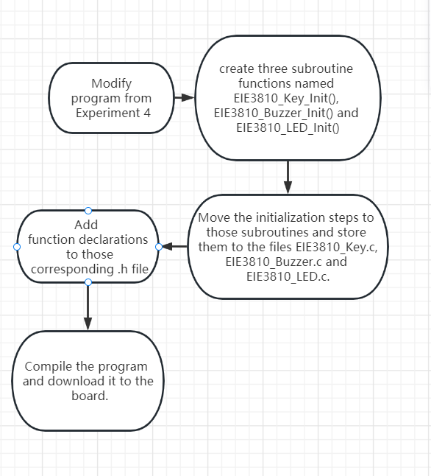

* + 1. Explanation of source code

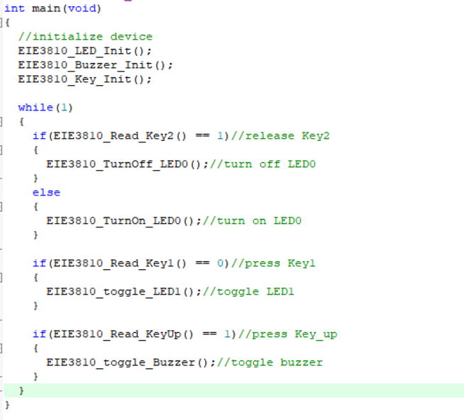

The only difference to experiment4 is using subroutines. Copy the content to functions, so we can just use the functions directly.

* 1. Result



From top to down, they are Key2, LED0, Key1, LED1, Key_up and buzzer.

When pressing Key2, LED0 is on. When releasing Key2, LED0 is off.

Key1 toggles LED1, i.e. press and release Key1, and LED1 status is then flipped.

Key_up toggles buzzer, i.e. press and release Key_up, and buzzer status is then changed.

* 1. Questions
     1. There no questions in the handout.

1. **Conclusion**

I first write codes to drive GPIO to light LED and noise buzzer with both standard library and register setting. It is very exciting and fantastic. I have learned how to use STM32F103ZET6 and firmware library. Besides, I understand how codes control the STM32 by registers. We can compare STM32 to computer. Buzzer is like sound equipment, LED is like screen, keys are like keyboard, my codes are like operating system. In some sense, I figure out how computer works.